**Parity is not associated with multiple measures of biological age:**

**Evidence from NHANES 1999-2010**

**Abstract**

Chronological age is the single best predictor of health and mortality, but same-aged individuals differ in their susceptibility to disease and functional decline. Understanding this variation in ‘biological age’ - and the factors that contribute to its acceleration - is essential for effective public health initiatives and interventions. One factor that could accelerate biological aging, especially among women, is reproduction. In women, pregnancy is characterized by extensive and energetically costly changes across numerous physiological systems. These changes, sometimes referred to as ‘costs of reproduction’ may accumulate with each pregnancy, accelerating the pace of biological aging. Despite evidence for costs of reproduction using molecular and demographic outcomes, it is unclear whether or not parity can be linked to commonly-used clinical measures of biological aging. Here, we use data collected between 1999-2010 from the National Health and Nutrition Examination Survey in the United States (n = 2,669) to test whether parity (number of live births) is associated with three previously-validated composite measures of biological age: Levine Method (LM), homeostatic dysregulation (HD), and Klemera-Doubal method (KDM) biological age. Parity was not associated with any measure of biological age in either pre- or post-menopausal women when controlling for chronological age, lifestyle, health-related, and demographic factors known to modulate biological age. These findings suggest that composite measures of biological age that integrate indices of function across multiple systems may not be sensitive enough to detect putative costs of reproduction in women, or that costs of reproduction may be acute rather than chronic or long-lasting. Future work, informed by our current understanding of the physiological changes associated with pregnancy, should continue to investigate links between parity and biological age using more targeted physiological measures and longitudinal study designs.

**1. Introduction**

Chronological age is a leading predictor of mortality, morbidity, and functional decline (Kennedy et al., 2014; Kirkwood, 2005). Despite the striking association between chronological age, lifespan, and health, individuals vary considerably in their rate of functional decline (Levine & Cimmins, 2018). This variation - attributed to differences in the biological rate of deterioration or repair - is referred to as ‘biological age’, and is thought to reflect the cumulative effect of environmental exposures in combination with underlying genetic variation. Understanding the environmental, behavioral, and physiological factors that influence biological aging may inform policies and interventions that could help to mitigate their effects, thereby extending the healthspan. Such policies and interventions will become increasingly important as the proportion of the global population over age 60 is expected to increase dramatically over the next 30 years (United Nations, 2019).

Environmental factors found to accelerate biological aging and functional decline include smoking (Valdes et al., 2005), obesity (Valdes et al., 2005), socioeconomic status (Hastings et al., 2019), and psychosocial stress (Epel et al., 2004). Another lifestyle factor that may accelerate biological aging in women specifically is reproduction (Pollack et al., 2018; Ryan et al., 2018). Reproduction in women is an energetically costly process, and is characterized by extensive changes in both form and function across numerous anatomical and physiological systems (Tan and Tan 2013; Blackburn 2014). Pregnancy and breastfeeding are accompanied by shifts in immune function (Cramer & Vitonis, 2018; Lurie et al. 2008, Faas et al. 2014, La Rocca et al. 2014, Aghaeepour et al. 2017), energy metabolism and storage (Soma-Pillay et al. 2016; Fried et al. 2017), blood pressure and volume (Sanghavi and Rutherford; Chung and Lafayette 2013), and hormone levels and receptor expression (Kovacs and Deal 2019). Evolutionary theory predicts that these changes should create functional or energetic constraints to somatic maintenance and defense, leading to accelerated biological age - a tradeoff referred to as ‘costs of reproduction’ (Harshman & Zera, 2007).

Consistent with costs of reproduction in women, ever-parity has been linked to mortality from diabetes, cancer of the uterine cervix, gallbladder disease, kidney disease, hypertension, and all-cause mortality (Beral 1985, Grundy 2009, Hurt et al. 2006, Lund et al. 1990). Similarly, women who give birth to more children are at higher risk of developing obesity, diabetes, hypertension and cardiovascular disease (CVD; Simons et al. 2012; Lawlor et al. 2003), as well as age-corrected all-cause mortality (Dior et al., 2013; Zeng et al. 2016, Lund et al. 1990), mortality related to cardiovascular disease (Lv et al. 2016) and mortality related to kidney disease (Guan et al. 2013). It is important to note that in the studies with the largest sample sizes (and presumably, the highest statistical power), parity exhibits a U-shaped association with all-cause mortality (Dior et al., 2013; Zeng et al., 2016) and cardiovascular disease (Lv et al., 2016), with highest levels of all-cause mortality and cardiovascular disease observed at lower and higher levels of parity, as compared to what is observed at intermediate levels. The number of children or pregnancies has also been linked to multiple measures of cellular aging, including DNA damage and oxidative stress (Ziomkiewicz et al, 2016), telomere length (Pollack et al., 2018; Ryan et al. 2018), and DNA methylation age (Kresovich et al., 2019; Ryan et al. 2018). While most of these studies examine associations within Western populations, some evidence supporting costs of reproduction is seen in non-Western populations as well (Ryan et al., 2018; Ziomkiewicz et al., 2016).

Cellular measures of biological age such as telomere length and DNA methylation age may provide insights into the molecular processes linking reproduction to mortality and other health outcomes (Harley et al.,1992; Horvath & Raj, 2018), and may eventually serve as early indicators of the costs of reproduction in health and aging. However, such cellular measures often require molecular assays which can be expensive and technically challenging, rendering their implementation difficult in standard clinical contexts and large epidemiological studies. What is unknown is whether it is possible to capture costs of reproduction in women using more easily measured, widely-used clinical measures of biological age.

Three composites of system integrity have been used to operationalize biological age within the context of large-scale epidemiological studies in the United States: Homeostatic Dysregulation (HD; Cohen et al, 2013), Levine Method Biological Age (LM; Levine et al., 2018; Liu et al, 2018), and the Klemera-Doubal Method Biological Age (KDM; Levine, 2013; Klemera & Doubal, 2006). These measures quantify changes in physiological integrity by combining information from multiple clinical biomarkers that collectively assess the functioning of major organ systems throughout the body, and exhibit robust associations with physical functioning, cognition, hearing and vision, and with self-reports of health and functional disability (Hastings et al., 2019). Importantly, energetic trade-offs between somatic maintenance and reproduction have been suggested to operate at the system level via the activity of neuroendocrine and sex hormones (Atwood & Bowen, 2011). Thus, in addition to providing more affordable and widely-applicable measures of biological age, composite indices may better approximate costs of reproduction.

The importance of assessing how parity affects clinical-based measures in addition to cellular-based measures of biological age is further highlighted when considering correlations between these two classes of measures. As ‘aging’ may refer to a wide range of processes that may occur at different times or at different speeds, low correlations between different indices of biological age are unsurprising. For example, cellular measures of biological age that examine mitotic (e.g., telomere length) and non-mitotic (e.g., DNA methylation age) processes are not correlated (Ryan et al., 2018). Similarly, HD and KDM show no association with telomere length and DNA methylation age (Belsky et al., 2018). It is thus clear that different measures of biological age index fundamentally different components of the aging process, and careful study of a range of such measures is required for a more complete understanding of costs of reproduction in women.

Here, we present nationally-representative estimates of the effect of parity (operationalized as number of live births) on three composites of system integrity indexing biological age. Using cross-sectional epidemiological data collected in the United States between 1999 and 2010, we test whether parity is associated with HD, KDM, and LM, while controlling for a range of covariates (e.g., smoking, obesity) known to modulate biological age to better isolate the unique contribution of parity on biological age. Although each measure utilizes the same panel of biomarkers, differences in scale construction provide a varied, multifactorial approach to the study of costs of reproduction on biological aging. Based on findings from the most highly powered prior studies of all-cause mortality and parity, we hypothesized a U-shaped relationship between parity and biological aging; specifically, that accelerated biological aging would be most apparent in women with the lowest and the highest parity. Our findings have significant theoretical implications for our understanding of the relationship between parity and health, and of putative tradeoffs between reproductive and somatic effort.

**2. Materials and Methods**

*Data source*

Data were collected as part of the Centers for Disease Control and Prevention’s National Health and Nutrition Examination Survey (NHANES). NHANES uses multistep cluster sampling, and assigns participants sample weights based on demographic variables such as self-identified race/ethnicity, age, and education; utilization of these sample weights in analyses enables estimation of population-level effects. Continuous sampling for NHANES began in 1999, and data is made publicly available in two-year waves. Details of recruitment procedures and study design are available from the Centers for Disease Control and Prevention (<https://www.cdc.gov/nchs/nhanes/>). Women sampled between 1999 and 2010 are included in the present analyses, as not all the data necessary to construct the biological aging measures (i.e. C-reactive protein) were released for cycles following the 2009-2010 cycle at the time of writing this manuscript. Furthermore, women missing information on any covariate included in analyses were excluded from the sample. A flowchart detailing sample stratification can be found in **Figure 1**, and sample demographic information is presented in **Table 1**.

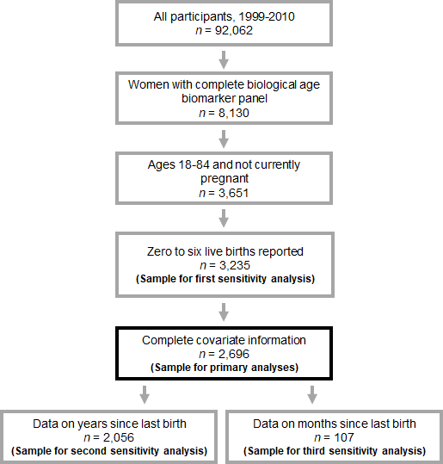

**Figure 1.** Flow chart illustrating sample stratification.

**Table 1.** Sample descriptive characteristics, National Health and Nutrition Examination Survey, 1999-2010 (*n* = 2,669).

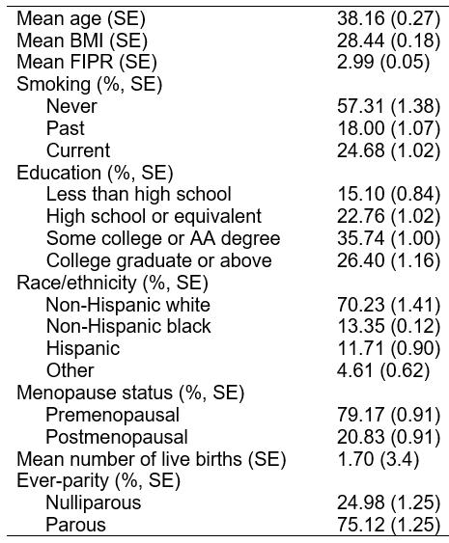

*Ethical approval*

All sampling procedures were approved through the National Center for Health Statistics Ethics Review Board, and all participants provide informed consent before sample collection and interviews.

*Reproductive health and parity data*

Women completed a computer-assisted questionnaire on their reproductive health history. Women reported whether they were currently pregnant, if they have ever been pregnant, how many pregnancies resulted in a live birth (if applicable), whether they had regular periods over the last 12 months, and their reason for not having regular periods over the last 12 months (if applicable). As previous work has suggested that current pregnancy modulates certain measures of biological age (Ryan et al., 2018), women who self-reported currently being pregnant were excluded from analyses. Number of live births was top-coded at 11 in data releases for confidentiality purposes. Thus, all live birth values represent discrete values with the exception of values coded as 11 (*n* = 1), which correspond to 11 live births or greater. Due to the small number of women with complete covariate information who reported 7 or more live births (n = 27), these women were excluded from analyses. The frequency distribution for women included in our analyses is displayed in **Figure 2**. Women who reported a prior live birth indicated their age at last live birth across all survey cycles. Because responses to this question were bottom-coded at 14 and top-coded at 45 for some cycles, we limited our analysis to women who reported an age of last live birth between 15 and 44. Starting in the 2007-2008 cycle, NHANES added a question on the number of months since last live birth for women who reported up to a two year difference between their current age and age of last birth.

Women were categorized as being pre-menopausal if they reported having regular periods over the last 12 months, if they reported not having regular periods because of a reason other than menopause, or if they were younger than 41. A lower limit of 41 was chosen because the average age of menopause in the US is 51, and perimenopause may last up to 10 years for some women (Lobo, 2013). Women were categorized as being post-menopausal if they were older than 61, or if they reported not having regular periods over the last 12 months because of menopause.

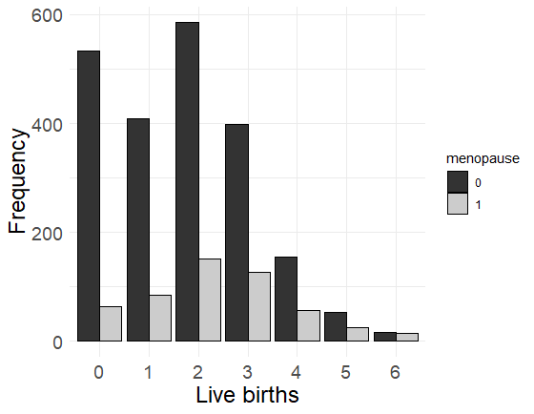

**Figure 2.** Distribution of live births for premenopausal (black bars; *n* = 2,148) and postmenopausal (gray bars; *n* = 521).

*Biological aging measures*

All composite measures of biological aging were constructed using the following 9 biomarkers: albumin, creatinine, glucose, log-transformed C-reactive protein (CRP), lymphocyte percent, mean cell volume, red blood cell distribution width, alkaline phosphatase, and white blood cell count. NHANES III, for which data collection ran between 1988 and 1994, were used as the reference sample for the construction of the biological aging measures employed here. Serum creatinine values from NHANES III and NHANES 1999-2004 continuous panels were adjusted according to published recommendations (Selvin et al., 2007).

Homeostatic Dysregulation (HD) is a measure of Mahalanobis distance (Mahalanobis, 1936) quantifying the deviation of a participant’s physiology from a young, healthy reference norm. Following previous work (Hastings et al., 2019), we defined our reference population as non-pregnant women from NHANES III aged 20-30 who were not obese (BMI<30) and for whom all biomarkers fell within the clinically normal range for their age and sex (N=482, see **ESM Tables 1-2**)**.** Biomarker values from the reference population were standardized and used to compute a biomarker variance-covariance matrix (**ESM Table 3**). Biomarker raw means, raw standard deviations, and the standardized-biomarker variance-covariance matrix are implemented within the Mahalanobis distance equation (Mahalanobis, 1936) to form the homeostatic dysregulation (HD) algorithm: . Here, *v* is a vector of biomarker values for a participant in the analysis sample; *u* is a vector of biomarker means in the training sample, and *S*is the standardized-biomarker variance-covariance matrix. As HD in the full sample was significantly skewed, log-transformed HD was used as the outcome variable in all analyses.

Klemera-Doubal Method (KDM) Biological Age is computed using the Klemera-Doubal equation (Klemera & Doubal, 2006), which extracts information from individual regressions of chronological age onto *m* biomarkers: 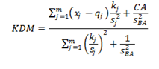 Here, *xj* is the value of biomarker *j* measured for an individual in the analytical sample and *CA* is their chronological age. For each biomarker *j*, the parameters *q* (intercept), *k* (slope), and *s* (root mean squared error) are estimated from a regression of chronological age onto the biomarker in the reference population. *sBA* is a scaling factor equal to the square root of the variance in chronological age explained by the biomarker panel in the reference population (Levine, 2013; Eq. 5). Following previous work (Levine, 2013), we formed our reference population from non-pregnant women in NHANES III aged 30-75 (N= 5,995, see **ESM Tables 4 and 5**). An individual's KDM Biological Age corresponds to the average chronological age at which their physiology would be observed in

the reference population.

Levine Method (LM) Biological Age is computed from a multivariate analysis of mortality hazards using NHANES III data (Levine et al., 2018; Liu et al., 2018). Herein, a multivariate Gompertz model of mortality hazard is fit to the selected biomarkers and chronological age to form a predicted hazard of mortality called a “mortality score”. This mortality score is converted to a biological age value using a second univariate Gompertz regression of the mortality hazard onto chronological age. In this manner, the LM biological age is interpretable as the chronological age at which an individual’s physiology-based risk for mortality would be approximately normal in the reference population. We applied published parameters from Liu and colleagues’ original work to compute LM biological age for participants in our sample.

We conducted analyses to estimate model parameters for HD scores and KDM biological ages using data from NHANES III. All three biological aging measures were computed using the same panel of 9 biomarkers. These biomarkers were selected based upon their inclusion in the LM biological age algorithm, which utilized machine-learning analysis to select the most parsimonious panel of biomarkers for mortality prediction. Biomarker summary statistics for the final analytical sample (*n* = 2,669) are provided in **ESM Table 6.**

Univariate distributions, bivariate distributions, and Pearson correlations coefficients for age, LM, log-transformed HD, and KDM are displayed in **Figure 3**. Expectedly, all three measures of biological age were significantly correlated with chronological age, and all three measures of biological age were significantly correlated with each other.

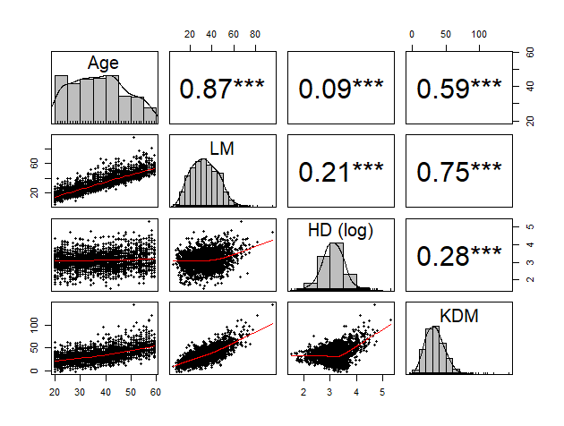

**Figure 3.** Associations between measures of chronological and biological age employed in the present study, National Health and Nutrition Examination Survey 1999-2010 (*n* = 2,669). Numbers represent Pearson correlation coefficients. Note: *** p < 0.001

*Covariates*

Self-reported race/ethnicity (Levine & Crimmins, 2014), socioeconomic status (SES; Steptoe et al., 2011; Robertson et al., 2013), body mass index (BMI; Müezzinler et al., 2014), and smoking (Valdes et al., 2005) moderate the relationship between chronological age and biological aging. Self-reported race/ethnicity was categorized as non-Hispanic (NH) white, NH black, Hispanic, and ‘other.’ SES was indexed by educational attainment and federal income-to-poverty ratio (FIPR). Height and weight were measured by an NHANES examiner, and BMI was calculated as weight (kg) divided by height (meters squared). As prior work has shown that BMI exhibits a U-shaped curve with negative health outcomes (Lewis et al., 2009), our models included both linear and quadratic terms for BMI. On the basis of responses to a computer-assisted questionnaire on smoking habits, women were classified as never, past, or current smokers. To better isolate the effect of parity and biological age, our primary models controlled for the aforementioned covariates.

*Statistical analyses*

All analyses were performed in R using the *survey* package, which supports functionality for analyzing data from complex survey designs. To facilitate accessibility of our methods, we also performed all analyses in Stata version 16.1. R scripts, Stata scripts, and data files have been uploaded as electronic supplementary material.

We followed all NHCS guidelines for the analysis of NHANES data ([NCHS, 2018](https://wwwn.cdc.gov/nchs/nhanes/AnalyticGuidelines.aspx)). As the survey weights relevant to the smallest sample subpopulation for which all data are available should be used, we used 2-year mobile examination center (MEC) weights to adjust for complex survey design, oversampling, non-coverage, day of the week, and survey nonresponse to compute nationally representative estimates (Korn & Graubard, 1999). Statistical significance was set to *p* < 0.05.

We estimated multiple linear regression models to examine the association of number of live births on biological age when controlling for chronological age, self-reported race/ethnicity, educational attainment, FIPR, BMI, and smoking. Separate models were estimated for LM, log-transformed HD, and KDM. We estimated both linear and quadratic terms for number of live births, as it has been previously suggested that the number of live births may exert quadratic, rather than linear, effects on morbidity and mortality (Dior et al., 2013; Lv et al., 2016; Zeung et al., 2016). As higher values correspond to more advanced biological age across all biological aging measures, a positive linear effect suggests a higher number of live births is associated with a higher biological age. A positive quadratic effect would suggest a convex (or U-shaped) shape to the fitted curve, while a negative quadratic effect would suggest a concave shape to the fitted curve. As some prior work suggests that costs of reproduction should be the most apparent after menopause (Westendorp & Kirkwood, 1998), we also included model terms for the main effect of menopause status and the interaction between menopause status and number of live births (see also Cramer & Vitonis, 2018).

Figure 3 was generated using Stata through post-estimation marginal standardization postestimation commands in Stata for regressions adjusting for the distribution of other covariates (Graubard & Korn, 1999). The y-axes in these figures represent the extent to which chronological age deviates from biological age. For KDM and LM, this deviation was calculated as the difference (in years) between chronological age and biological age. For log-transformed HD, this represents the difference between actual chronological age and chronological age predicted by biological age (i.e. the residual of chronological age regressed onto log-transformed HD). In all three cases, positive values indicate aging deceleration (chronological age > biological age) while negative values indicate age acceleration (chronological age < biological age).

*Sensitivity analyses*

We conducted a series of follow-up regressions to probe the robustness of our primary analyses. First, we repeated the multiple linear regressions exactly as described above, including only chronological age as a covariate. This was done to ensure the relationship between variables included in our primary analyses and biological age were so strong as to masking putative relationships between parity and biological age. For example, in our sample BMI was significantly, positively correlated with LM and KDM (*r* = 0.29 and 0.28, respectively; *p* < 0.001).

We then estimated a second set of sensitivity analyses, with time since last birth used to create additional model terms. We chose these as sensitivity analyses rather than primary analyses for two reasons. First, models including time since last birth by default eliminate all nulliparous women, rendering us unable to calculate estimates for the effect of parity for nulliparous women. Second, data on time since last birth were missing for a significant portion of our sample. In these models, we assessed the extent to which effects of parity may be chronic and accumulate over time, or acute and only present in the postnatal period. To assess potential chronic effects, years since last birth was calculated for women across all survey cycles as age of last live birth subtracted from current chronological age. To assess potential acute effects data on months since last birth was available for women sampled in the 2007-2008 and 2009-2010 cycles. We estimated one set of regressions exactly as described above for our primary analyses, and added terms for the main effect of years since last birth and interactions between years since last birth and parity. We then estimated a second set of regressions exactly as described above for our primary analyses and added terms for the main effect of months since last birth and interactions between months since last birth and parity; however, since data on months since last birth were not available for any postmenopausal women, main and interactive effects of menopausal status were not included.

**3. Results**

Across all three models (*n* = 2,669), chronological age, BMI, and smoking status exhibited statistically significant, anticipated relationships with LM, log-transformed HD, and KDM, with increasing chronological age and being a current smoker being associated with higher biological age (see **Table 2**). There were no consistent patterns of statistical significance for the effect of other included covariates on LM, log-transformed HD, and KDM across models.

The linear effect of number of live births was not significant in any model (LM estimate = -0.39, *p* = 0.115; log(HD) estimate = 0.003, *p* = 0.894; KDM estimate = -0.76, *p* = 0.208); similarly, the quadratic effect of number of live births was not significant in any model (LM estimate = 0.06, *p* = 0.238; log(HD) estimate = -0.003, *p* = 0.559; KDM estimate = 0.04, *p* = 0.746; see **Table 2** and **Figure 4**). There was a main effect of menopause status in predicting HD and KDM (log(HD) estimate = 0.15, *p* = 0.024; KDM estimate = 4.03 , *p* = 0.042), with higher scores in menopausal women (independent of age). While the overall curve for menopausal women appeared more U-shaped relative to that of premenopausal women, the interaction between menopause status and the linear effect of number of live births was not significant in any model (all *p* > 0.086), nor was the interaction between menopause status and the quadratic effect of number of live births (all *p* > 0.260).

*Sensitivity analyses*

Sample sizes for our sensitivity analyses controlling for chronological age only were slightly larger (*n* = 3,235), as less participants were excluded due to missing covariate information. LM and KDM exhibited significant associations with one another, but neither was significantly correlated with log-transformed HD. Linear and quadratic effects of number of live births, and interactions between menopause status and number of live births, were not significant in any model (see **ESM Table 7**).

Of the 2,669 women in our primary analyses, data on years since last live birth were available for 2,056. The average years since last live birth was 11.86 (SE = 0.21). The main effect of years since last live birth was not significant in any model, nor were any of the interaction terms between years of last live birth and parity (see **ESM Table 8**).

Our sample size for analyses including months since last live birth (*n* = 107) was significantly limited by the fact that this subsample excluded all postmenopausal women, and excluded women sampled prior to this question being added in the 2007-2008 cycle. Because of this limited sample size, these results should be interpreted as exploratory only. On average, women with valid responses to this question gave birth 10.88 months ago (SE = 0.25). While the main effect of months since last live birth, as well as the interactions between months since last live birth and the linear and quadratic terms for last live birth, were significant in predicting LM, none of these effects were statistically significant in predicting log-transformed HD and KDM (see **ESM Table 9**).

**Table 2.** Multiple linear regression examining the effects of number of live births on biological age, National Health and Nutrition Examination Survey 1999-2010 (*n* = 2,669). *Notes:* * *p* < 0.05, ** *p* < 0.01, *** *p* < 0.001; BMI = body mass index; FIPR = federal income-to-poverty ratio

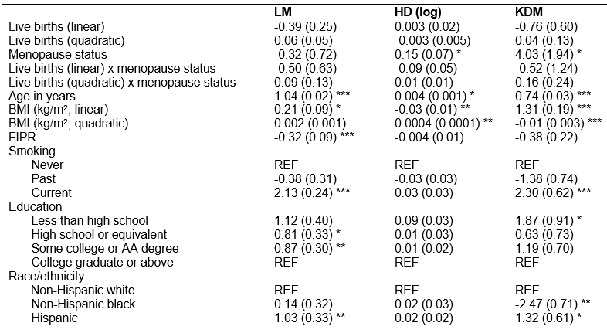

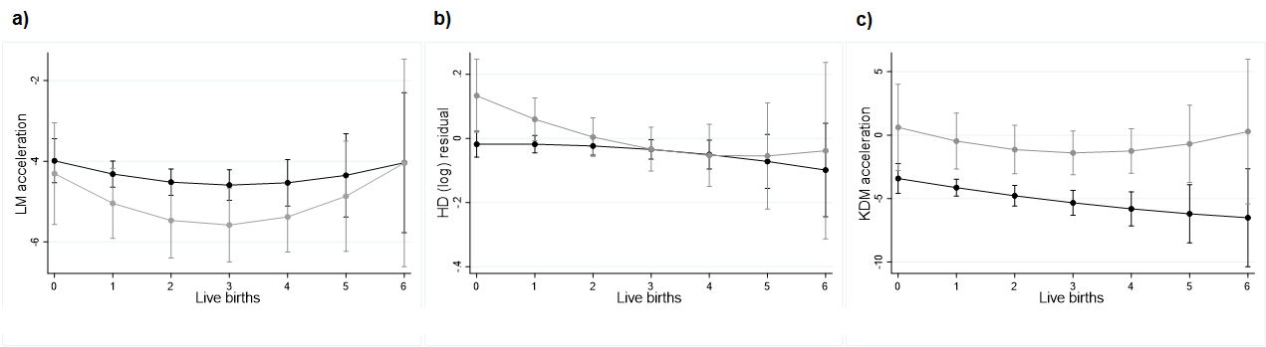

**Figure 4.** Predicted values and 95% confidence intervals for LM age acceleration (panel A), HD acceleration (panel B), and KDM age acceleration (panel C) among premenopausal women (black line) and postmenopausal women (grey line), National Health and Nutrition Examination Survey (*n* = 2,669). *Note:* Figure generated using marginal standardization adjusted for the distribution of age, BMI, FIPR, smoking, education, and race/ethnicity.

**4. Discussion**

Our primary aim was to examine putative physiological costs of reproduction, as indexed by three validated measures of biological age among a nationally-representative sample of US women of reproductive and post-reproductive age. Based on prior work, we hypothesized a U-shaped relationship between parity and biological age. When controlling for lifestyle, health-related, and demographic factors, parity (defined as number of live births) was not significantly associated with any of the three measures of biological age examined, nor did the association between parity and biological age differ as a function of menopause status. To our knowledge, our study represents the first application of biological age composites indexing system integrity (LM, HD, KDM) to quantify costs of reproduction in women. The lack of clear associations between parity and LM, HD, and KDM can be explained in several ways. In what follows, we describe what we view as the most tenable hypotheses.

First, it is possible that reproduction may exert significant physiological effects, but that the proxies used in LM, HD, and KDM are imprecise measures of the effects they aim to index. For example, NHANES white blood cell count data reflects the total number of white blood cells, and does not distinguish between different cell types. Total white blood cell count is significantly increased during pregnancy, but returns to baseline within two years postpartum (Kieffer et al., 2017). By contrast, higher proportions of CD4+ effector memory cells and CD8+ lymphocytes (Kieffer et al., 2017), higher lymphocyte-monocyte ratios (Cramer & Vitonis, 2018), and lower platelet-lymphocyte ratios (Cramer & Vitonis, 2018) are retained in parous women as compared to nulliparous women. This differential composition of white blood cells types as a function of parity suggests that while reproduction does alter immune function, total white blood cell count may be too coarse of a measure to detect shifts in immune function in this context. Similarly, while alkaline phosphatase levels are correlated with bone mineral density (Park et al., 2010), work in mice suggests that parity exhibits a dose-response relationship with bone mineral density in absence of significant changes in alkaline phosphatase levels (Gu et al., 2017).

The inclusion of proxies in LM, HD, and KDM composites that do not accurately capture reproduction-induced changes across the systems they are hypothesized to reflect may in turn dilute the effects of better proxies that are indeed associated with parity. For example, low grade albuminuria risk increases with parity (Sun et al., 2019), and it is possible that relationships between parity and albumin (included in our composites) were obscured by the inclusion of more coarse proxies, as detailed above.

A second and not mutually exclusive hypothesis is that reproduction exerts significant effects, but that these effects differ in whether they are acute or chronic in nature. In addition to transient changes in global white blood cell counts, other markers of immune function, such as IL-6, TNF-α, and CRP (included in our composites) increase across pregnancy, but return to pre-pregnancy levels within four months postpartum (Stewart et al., 2007; Kuzawa et al, 2013). Other indices may change across pregnancy and return to pre-pregnancy levels even faster, such as glomerular filtration rate (an indicator of kidney function) which returns to baseline levels within one week postpartum (El-Mahallawi et al., 1968), or systolic blood pressure which returns to baseline levels shortly after birth (Grindheim et al., 2012). Yet, other indices of cardiovascular function such as ventricular volumes and cardiac output that change across pregnancy continue to exhibit differences from baseline values at one year postpartum (Clapp & Capeless, 1997). Roughly half of women who develop gestational diabetes continue to be diabetic after pregnancy (Buchanan et al., 2012), suggesting a chronic effect of pregnancy on glucose metabolism. Measures of cellular aging exhibit both chronic (Ziomkiewicz et al, 2016; Pollack et al., 2018) as well as acute (Ryan et al. 2018) responses to pregnancy. Taken together, pregnancy or lactation may be associated with both acute and chronic changes across different systems, and that even within the same physiological system, costs may be both acute and chronic depending on the measure. As a result, the measures included in our biological age composites could be acutely, but not chronically, affected by reproduction, if they are affected at all. Though our sensitivity analyses did not consistently suggest a statistically significant effect of time since last live birth on measures of biological age (suggesting a lack of acute effects), data at finer timescales is needed to better understand changes potential transient changes in biological age markers perinatally.

A third hypothesis is that the measures included in our biological aging composites do in fact accurately index the integrity of systems they represent, and that reproduction is not associated with any chronic costs in these systems. While this hypothesis is supported by studies finding no link between parity and all-cause mortality (Chereji et al., 2013), it contradicts others that do find a link (Dior et al., 2013; Zeng et al. 2016, Lund et al. 1990), and further contradicts other research linking parity with other health outcomes, such as type II diabetes and cardiovascular disease (Simmons et al., 2012; Lawlor et al., 2003).

*Limitations*

The fact that NHANES is cross-sectional rather than longitudinal in design contributes to two significant limitations in our study. First, its cross-sectional nature does not allow us to draw conclusions about causal relationships (or lack thereof); thus, it is crucial that future work follow women as they transition from nulliparity to parity, and as they continue to reproduce, to best evaluate causal relationships between reproduction and biological age. However, should a causal relationship between chronic effects of parity and biological age exist, this should have been apparent in our cross-sectional data, especially given the low levels of error or bias in reporting the number of live births. Second, we are only able to examine relatively chronic, rather than acute, effects of reproduction on biological age given the current study design. Longitudinal studies, ideally with dense sampling schedules, would better enable us to assess the time scales at which costs of reproduction may be apparent. Frequently sampling women before, during, and after pregnancy would allow for the investigation of putative acute and chronic changes in markers and composites of biological age. Women’s prenatal health also predicts both pregnancy outcomes (Negrato et al., 2012; Seely & Ecker, 2014), as well as postnatal health risks. As such, longitudinal studies are necessary to understand what factors moderate reproduction-related changes in biological age across women.

Another limitation is that BMI is an important contributor to observed differences in biological age (Müezzinler et al., 2014). Changes in body mass and adiposity are central to the physiological changes occuring with pregnancy as women begin “metabolizing for two” (Ellison, 2001). Parity is associated with increased central adiposity (Gunderson et al, 2004), and pregnancy-related weight gain can mediate associations between obesity and long-term morbidity (Rooney, Schauberger, & Mathiason, 2005). These risks might be reduced by breast-feeding, which acts to mobilize accumulated fat and reset maternal metabolism (Stuebe & Rich-Edwards, 2008). As NHANES does not include fine-grained data on lactation practices, we were unable to examine the additive effects of parity and lactation on biological age. Both cross-sectional and longitudinal future studies should aim to more fully quantify pre- and post-natal factors indexing reproduction-related energetic investment.

Finally, because data were collected in the United States, it is unknown whether similar patterns would be observed outside the context of WEIRD (Western, Educated, Industrialized, Rich, and Democratic; Henrich et al., 2010) samples. WEIRD and non-WEIRD countries are characterized by significantly different activity patterns, nutrition, infectious disease ecology, and morbidity and mortality (Gurven & Lieberman, 2020), all of which could shape how reproduction affects women’s health and hence, costs of reproduction. Non-WEIRD countries are also characterized by higher parity (Sear et al., 2016). It is possible that the parity in our sample was too restricted in range to detect extant parity-biological age associations, and based on our sample, we cannot make estimations about the nature of these associations in women who report more than six previous live births. Whereas some studies have indeed examined links between parity and aging in non-Western settings (e.g., Ryan et al., 2018; Gurven et al. 2016), more research is necessary to better catalogue and understand cross-cultural variation in costs of reproduction in women.

*Conclusions*

We analyzed links between parity and different measures of biological aging using a large, nationally-representative epidemiological sample of pre- and post-menopausal women in the United States. Our results do not suggest a linear or quadratic relationship between parity and accelerated biological age in women, when biological age is measured using coarse clinic- and lab-based measures of physiological function. Future work should employ longitudinal designs, include a broader range of measures, collect more detailed data on variables quantifying energetic investment in reproduction, and utilize system-specific measures of biological age to more fully elucidate costs of reproduction and the time scales in which they are apparent.

**Funding**

TS: National Science Foundation

WH: National Institute on Aging T32AG049676

CR: National Science Foundation, Natural Sciences and Engineering Research Council of Canada (NSERC)

AR: none.

**Authors’ roles**

TS, WH, and CR contributed to the study conceptualization, data analysis, data interpretation, and manuscript writing. AR contributed to data analysis, data interpretation, and manuscript writing. All authors have approved of the submitted manuscript.

**Conflict of interest**

The authors have declared that no conflicts of interest exist.

**Data availability**

All data and script files have been uploaded as electronic supplementary material.

**ESM**

**ESM Table 1.** Ranges of biomarker values used to restrict the reference population for Homeostatic Dysregulation (HD) algorithm.

|  |  |  |
| --- | --- | --- |
|  | **Units of Measure** | **Range** |
| Albumin | g/L | 35 - 50 |
| Creatinine | mg/dL | 0.59 - 1.04 |
| Glucose | mg/dL | <126 |
| CRP | mg/L | <3 |
| Lymphocyte Percent | % | 28 - 55 |
| Mean (red) cell volume | fL | 78.2 - 97.9 |
| Red Cell Distribution Width | % | 12.2 - 16.1 |
| Alkaline Phosphatase | U/L | 35 - 104 |
| White Cell Count | 1000 cell/uL | 3.4 - 9.6 |
| From https://www.mayocliniclabs.com/test-catalog/Clinical+and+Interpretive/ | | |

**ESM Table 2.** Descriptive statistics for the reference population used to define the Homeostatic Dysregulation (HD) algorithm

|  |  |  |  |
| --- | --- | --- | --- |
|  |  | Women (n = 482) | |
|  | UNITS | **𝜇** | **𝜎** |
| Age | Yrs | 24.97 | 3.10 |
| Albumin | g/L | 41.58 | 3.24 |
| Creatinine | umol/L | 65.95 | 6.70 |
| Glucose | mmol/L | 4.81 | 0.38 |
| CRP | ln(mg/dL) | -1.36 | 0.47 |
| Lymphocyte Percent | % | 38.19 | 6.35 |
| Mean cell volume | fL | 88.55 | 3.98 |
| Red cell width | % | 12.98 | 0.68 |
| Alkaline Phosphatase | U/L | 66.90 | 15.38 |
| White Cell Count | 1000 cell/uL | 6.29 | 1.42 |

**ESM Table 3.** Biomarker variance covariance matrix for the reference population used to define the Homeostatic Dysregulation (HD) algorithm

|  |  |  |  |  |  |  |  |  |  |
| --- | --- | --- | --- | --- | --- | --- | --- | --- | --- |
|  | Albumin | Creatinine | Glucose | Ln(CRP) | Lymphocyte Percent | Mean Cell Volume | Red Cell Width | Alkaline Phosphatase | White Cell Count |
| Albumin | 1.00 | 0.06 | -0.06 | -0.22 | -0.04 | 0.20 | 0.00 | -0.02 | 0.12 |
| Creatinine | 0.06 | 1.00 | -0.05 | -0.04 | 0.07 | 0.02 | -0.03 | -0.02 | -0.03 |
| Glucose | -0.06 | -0.05 | 1.00 | 0.02 | -0.07 | 0.00 | -0.03 | 0.05 | -0.07 |
| Ln(CRP) | -0.22 | -0.04 | 0.02 | 1.00 | -0.05 | -0.05 | 0.02 | 0.10 | 0.09 |
| Lymphocyte Percent | -0.04 | 0.07 | -0.07 | -0.05 | 1.00 | 0.00 | 0.09 | -0.15 | -0.28 |
| Mean Cell Volume | 0.20 | 0.02 | 0.00 | -0.05 | 0.00 | 1.00 | -0.38 | -0.05 | 0.02 |
| Red Cell Width | 0.00 | -0.03 | -0.03 | 0.02 | 0.09 | -0.38 | 1.00 | 0.08 | -0.05 |
| Alkaline Phosphatase | -0.02 | -0.02 | 0.05 | 0.10 | -0.15 | -0.05 | 0.08 | 1.00 | 0.15 |
| White Cell Count | 0.12 | -0.03 | -0.07 | 0.09 | -0.28 | 0.02 | -0.05 | 0.15 | 1.00 |

*Note:* Biomarkers were standardized to mean=0, standard deviation=1 prior to computing the variance covariance matrix.

**ESM Table 4.** Biomarker descriptive statistics for the reference population used to build the Klemera-Doubal Method (KDM) biological age algorithm (N=5,995).

|  |  |  |  |
| --- | --- | --- | --- |
|  | **Units** | **Mean** | **SD** |
| Age | Yrs | 50.04 | 13.69 |
| Albumin | g/L | 40.46 | 3.37 |
| Creatinine | umol/L | 66.04 | 14.35 |
| Glucose | mmol/L | 5.76 | 2.16 |
| Ln(CRP) | ln(mg/dL) | -1.02 | 0.77 |
| Lymphocyte Percent | % | 33.92 | 8.43 |
| Mean cell volume | fL | 88.83 | 5.66 |
| Red cell width | % | 13.26 | 1.14 |
| Alkaline Phosphatase | U/L | 86.57 | 28.70 |
| White Cell Count | 1000 cell/uL | 7.16 | 2.10 |

*Note:* The reference sample consisted of non-pregnant women aged 30-75 participating in NHANES III.

**ESM Table 5.** KDM biological age model parameters estimated from NHANES III reference sample. We report the intercept (Q), slope (K), and root mean squared error (S) for the regressions of biomarkers onto chronological age in the NHANES III reference sample. Rchar refers to a ‘characteristic correlation’ describing a summary relationship between the biomarker panel and chronological age. SBA2 corresponds to the squared variance in chronological age explained by the biomarker panel in the reference sample.

|  |  |  |  |
| --- | --- | --- | --- |
|  | **Intercept** | **Slope** | **RMSE** |
| Albumin | 41.545 | -0.022 | 3.361 |
| Creatinine | 52.070 | 0.279 | 13.836 |
| Glucose | 4.094 | 0.033 | 2.114 |
| Ln(CRP) | -1.228 | 0.004 | 0.766 |
| Lymphocyte Percent | 34.673 | -0.015 | 8.426 |
| Mean cell volume | 86.302 | 0.050 | 5.615 |
| Red cell width | 13.077 | 0.004 | 1.135 |
| Alkaline Phosphatase | 55.182 | 0.628 | 27.385 |
| White Cell Count | 7.528 | -0.007 | 2.101 |
|  |  |  |  |
| rchar | 0.277 | | |
| SBA2 | 870.150 | | |

**ESM Table 6.** Biomarker summary statistics for the final analytical sample (N=2,669).

|  |  |  |  |
| --- | --- | --- | --- |
|  | **Units** | **Mean** | **SD** |
| Age | Yrs | 37.52 | 10.57 |
| Albumin | g/L | 41.56 | 3.15 |
| Creatinine | umol/L | 64.77 | 11.64 |
| Glucose | mmol/L | 5.50 | 1.25 |
| Ln(CRP) | ln(mg/dL) | -1.39 | 1.26 |
| Lymphocyte Percent | % | 31.11 | 7.95 |
| Mean cell volume | fL | 88.42 | 5.85 |
| Red cell width | % | 12.83 | 1.22 |
| Alkaline Phosphatase | U/L | 67.46 | 21.86 |
| White Cell Count | 1000 cell/uL | 6.86 | 1.95 |

**ESM Table 7.** Nationally-representative coefficient estimates (and standard errors) from sensitivity models on the effects of number of live births on biological age when including chronological age as the only covariate (*n* = 3,235), National Health and Nutrition Examination Survey 1999-2010. Note: * *p* < 0.05, ** *p* < 0.01, *** *p* < 0.001 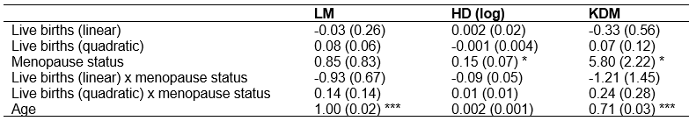

**ESM Table 8.** Coefficient estimates (and standard errors) from sensitivity analyses on the effect of number of live births and years since last live birth on biological age (*n* = 2,056), National Health and Nutrition Examination Survey 1999-2010. Note: * *p* < 0.05, ** *p* < 0.01, *** *p* < 0.001

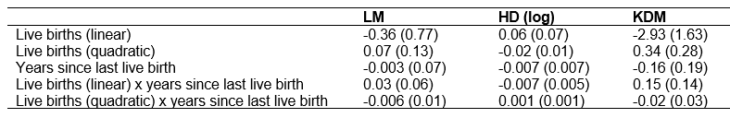

**ESM Table 9.** Coefficient estimates (and standard errors) from sensitivity analyses on the effect of number of live births and months since last live birth on biological age (*n* = 107),, National Health and Nutrition Examination Survey 2007-2010. Note: * *p* < 0.05, ** *p* < 0.01, *** *p* < 0.001

